**Quiz:**

A. Please explain web server, web browser, url.

* **Web Server:**  Web server is a computer or a system which hosts the website. This computer mainly uses Hypertext Transfer Protocol (HTTP) along with other protocols to process and deliver the webpages requested by the client\user over world wide web (WWW). A web server consists of a software as well as a hardware component. The software component (application software) determines how users access the web pages. The hardware component connects to the internet, manages the operating software of the server, the files of the website and allows data/page exchange amongst the connected systems. It sends the files and collects data from client systems.
* **Web Browser:** Web browser is a software which allows browsing/searching for data over the world wide web. Client systems (user systems) require the Web browser software applications to request data on internet. Web browsers allow users to type the URL of the website\application to enter and request data from web server hosting that particular website. The response sent by web server is often in the form of HTML page and the result can be rendered on the web browser.
* **URL:** Uniform Resource Locator (also known as the web address) points to the specific address or a reference to the resource on the world wide web. URL consists of a domain name and protocol which indicates how and from where the resource needs to be retrieved. The first part of the URL is used to identify which protocol will be used (http, FTP, https etc) and the second part or the domain name identifies where the resource is located. Users enter the URL in their system’s web browser. URL protocols are often followed by a colon and two forward slashes. Apart from the protocol and domain, a URL can also have the file path after it, a specific network port number, query string parameter.

B. What is difference between html and http?

* The main difference between html and http is that html is a markup language used to build the webpages, whereas http is a transfer protocol which is used amongst the client and server machines to communicate\exchange the webpages\data the user has requested.
* HTML is the language of webpages which uses various tags like <head>, <body>, <title> to design and build the pages. It’s a core language used to code and publish the website.
* HTTP is a part in the URL which indicates that a user is looking for the data from a particular website. It establishes the standard that a client\server system use for communication and data transfer using web browsers.

C. What is the usage of page structure tags(<html>, <head>, <body>)? Can you work without them?

* HTML is a markup language which uses tags for web page design. The tags are keywords which define how the web page should be formatted when rendered in the web browser. The HTML structure tags are required so that web browser can understand the file and display it in proper format. Without the structure tags, the file will be just considered as a text file and would not be readable or understood by the web browser.
* The <html> tag denotes the beginning and end of the HTML file. All the other tags are present inside the <html> tag.
* <head> tag also known as the header, contains the meta tags, style tags, title of file, author and other information which is not displayed on the browser but is required to either locate or format the web page.
* <title> is used to add the title which will be displayed in the title bar of a web browser.
* <body> tag contains the main content and all the information which is visible on the page.

D. What is <title> tag used for?

* <title> is used to add the title of the document which will be displayed in the title bar of a web browser. The title is a text only element which can also be used to bookmark the favorite pages.
* Title content is very important because it is used by search engine algorithm to decide the order when page results are listed.

E. Can you identify difference between <div> and <p> tag when styling a page?

* Even though both <div> and <p> tags are the block level elements, the <div> tag allows other block tags to be nested inside it whereas we can not nest any block within a <p> tag.
* The web browser will also automatically render a line break before and after the content added for <p> tag but the line breaks are not auto rendered for <div> tag.

F. Provide tags for different levels of headings that HTML support?

* There are total 6 levels of headings that HTML supports.
* H1, H2, H3, H4, H5 and H6. H1 is the most important and biggest level whereas H6 is the least important and lowest level. Every heading has the line break rendered before and after the heading.
* H1 is the main heading of the page and is supposed to be used only once in a page.

G. Joe is a potential Fall 2019 UMD student. He wants to submit his application files to UMD admission website. Draw a diagram to illustrate how Joe’s machine communicates with UMD website to return UMD admission page.

* Joe’s enter UMD admission website’s URL in his browser and clicks enter. The browser sends http request over internet to UMD admission website’s application server.
* The application server performs the validation call and responses to request by sending the copy of a requested web page to Joe’s system.
* This web page (html page) is rendered on Joe’s web browser.

**UMD Admission website URL is entered**

**Client/ Joe’s System**

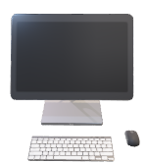

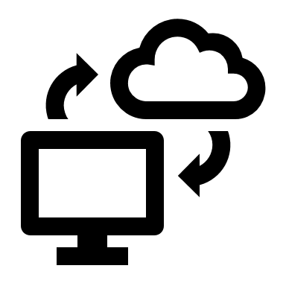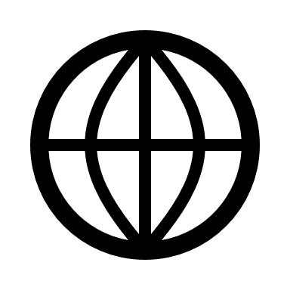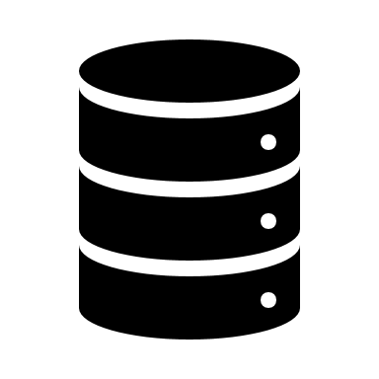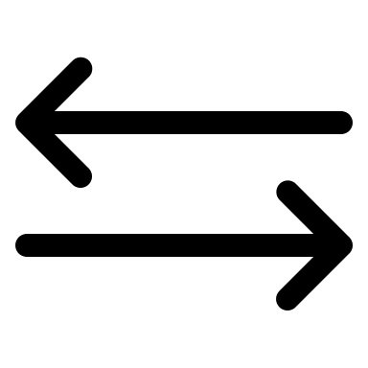

**Internet**

**Sends request for admission page using http**

**UMD Web Server (Application Logic)**

**Database and DBMS**

**Validation**

**HTML Page**

**Success**

**Fetches the page and sends as a POST response**

**Page is rendered on the user’s web browser**

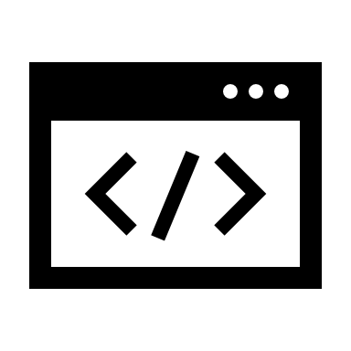

**Joe’s Web Browser Application**